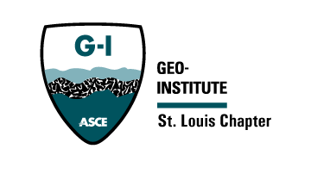


St. Louis Chapter of the Geo-Institute

Agenda

Meeting Date and Time: January 22, 2025

Attendance: Dale Miller, Shari Cunningham, Travis Kassebaum, Beya Kazadi, Xiaomin You, Dennis Boll, Jonathan Urton, Zach Fallert, Greg Hempen

Meeting Location: Frisco Barroom

- Structural and Geo-Confluence 2024 – Debrief
No new updates
- Finance Update, current Fiscal Year

- Communications
  - GeoStrata article should be upcoming

- Scholarship Awardees
None
- Student Sponsorships
None
- ASCE/AEG Social
Today! - Frisco
- March Luncheon
  - Kip is lined up as speaker

- Spring Seminar Event Discussion
  - Case Histories
  - April 23rd

- Adopt an Engineer
  - Had first student interaction early December

- Best Chapter – Won
  - GeoFrontiers – Beya and Travis will be attending.
  - March 2-5
  - Louisville, KY
  - Look for good presenters to reach out for geo-confluence

- University Program Updates Discussion for GI Chapter?
  - Regular updates from GI student chapter organizations in newsletter?
  - Zach will be following up on Student chapter coordinators
- February 11th – Kappe Lecturer
  - Zach to create a collaborate registration link to be included
  - Travis to reach out to Ronaldo to discuss drink/food logistics on 2/11. Confirm with Dr. Burken on formality, etc.
- Reach out to Krystina about cross usa lecturer as benefit to Best Chapters

- MSPE/ASCE February 5th – Meet with legislators
  - Jefferson City, MO
  - Reach out to Alison Graves
  - Add item to ASCE Website

- Next meeting:
  - Date and Time: February 20th, 8:00am
  - Location: TEAMS

